APPLICATION

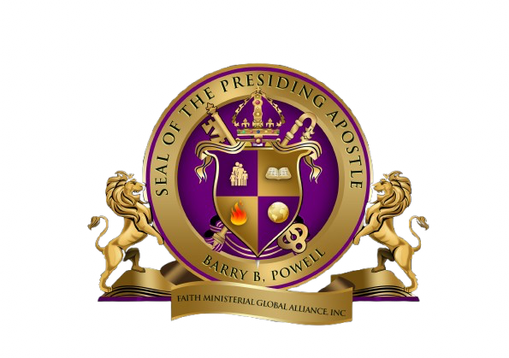

“It’s About Relationship”

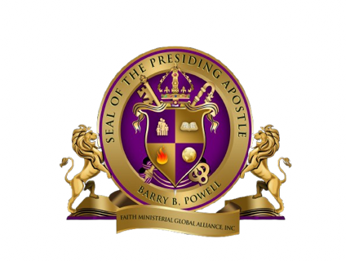

MINISTRY COVERING APPLICATION

Affix Photo Here
Complete application in its entirety, using a typewriter, or hand print in ink. Place a recent photo in the area provided (photo will be used in the FMAI membership directory). Enclose annual membership fee of $200.00 (per applicant).
Circle One:
Pastor Minister Dr. Mr. Mrs. Miss

Name: Last First Middle Maiden

Address: Street City State/Province Postal Code/Zip

Region/Country: Phone Number: Home ( ) Business ( ) Mobile ( ) Fax ( ) Email
Date of Birth: Age: Place of Birth: Sex: ______
Country of origin

Marital Status: Married Single Widowed Separated Divorced Name of Spouse:
Personal Information:
Names and Ages of Your Children:

Name: Age: Name: Age:

Name: Age: Name: Age:

Current Employer/Occupation:

Name of Employer: Address: Zip:
Education:
List all educational institutions attended (beginning with high school):
Name of School: Dates: Major: Diploma of Degree: 1.
2.

3.

Ministry Information:
Ministry Name: Ministry Address: Date of Salvation: Where: Have you been filled with the Holy Spirit with the evidence of speaking with other tongues?
In which field of ministry do you feel you are called?

Pastor Teacher Evangelist Missionary Apostle Prophet Other Explain:

Are you a Licensed Minister? Yes/No Date:

Are you Ordained? Yes/No Date:

Give a brief history of your ministerial experience (church pioneered or pastored, evangelistic meetings, business startups, etc.)

What minister or ministry provided your most recent prayer covering? Name:
Address:

Are you in agreement with the Statement of Faith and Guidelines for Membership Church Covering of FMA (see attached)? Yes No

Please include a brief testimony describing your call to ministry. (Use a separate sheet if necessary.)

If at any time I feel I can no longer agree with the attached statements and practices, I voluntarily forfeit my membership and/or ministerial credentials received from FMA.

Signature of Applicant: Date:

FMAI Statement of Faith

This fellowship accepts the Holy Scriptures as the revealed will of God, the all-sufficient rule for faith and practice, and for the purpose of maintaining general unity, adopts the following statement of funda- mental truths:

We believe the Bible to be the inspired and only infallible, authoritative Word of God.

We believe that there is one God; eternally existent in three persons: God the Father, God the Son, and God the Holy Spirit.

We believe in the deity of our Lord Jesus Christ, His virgin birth, His bodily resurrection. His ascension to the right hand of the Father, and in the blessed hope of His personal, visible, future return to this earth to receive to Himself His blood- bought church that it may be with Him forever.

We believe that the only means of being cleansed from sin is through repentance and faith in the precious blood of Christ.

We believe that regeneration by the Holy Spirit is absolutely essential for personal salvation.

We believe that the redemptive work of Christ on the cross provides healing of the human body in answer to believing prayer.

We believe, according to Acts 2:4, that the baptism with the Holy Spirit, with the evidence of speaking in other tongues is given to Believers who ask for it.

We believe in the sanctifying power of the Holy Spirit by whose indwelling the Christian enables them to live a holy life.

We believe in the resurrection of both the saved and the lost, the one to everlasting life and the other to everlasting damnation.

Mail To:

Faith Ministerial Alliance International
P.O. Box 10376
Daytona Beach, Florida 32120
Phone: 1.800.543.1345
1.386.366.1783
Email: faithministerial@gmail.com

